**ALUMNI WEBSITE**

**Submitted to the University of Madras in partial fulfilment of the requirements for the award of the degree of**

**MASTER OF SCIENCE IN**

**INFORMATION TECHNOLOGY**

**Submitted By**

**ABINAYA.S - (35121001)**

**SANGEETHA.B - (35121010)**

**GANESH - (35121014)**

**RAGHULMANI - (35121016)**

**SARANRAJ.V - (32121018)**

**Under the guidance of**

**DEEPASHRI.V**

**Guest Lecturer**



**DEPARTMENT OF NETWORK SYSTEMS AND INFORMATION TECHNOLOGY**

**UNIVERSITY OF MADRAS GUINDY,**

**CHENNAI-600 025.**

**UNIVERSITY OF MADRAS**

**DEPARTMENT OF COMPUTER SCIENCE**

**GUINDY – 600 025.**

**BONAFIDE CERTIFICATE**

This is to certify that the Major Project work entitled “ALUMNI WEBSITE**”** submitted to the University of Madras, Guindy by name(Register No:) in partial fulfilment of the requirements for the award of the degree **MSc Information Technology** is a bonafide record of the project work carried out by him during the academic period July -November 2022.

**Project Guide Head of the Department (Dr. PL. Chithra)**

Submitted for the project Examination held on. at the University of Madras, Guindy – 600025.

**Internal Examiner External Examiner**

**ACKNOWLEDGEMENT**

We thank “The Power” , the soul the guided me throughout the steps that we have taken. We think him once again for giving such a wonderful life full of colour and brightness that takes the path of Love and Care.

We are proud and privileged to express our sincere gratitude to thank and praise **Ms.V.Deepashri Guest Lecturer** , Department of Network systems and Information Technology University of Madras, Guindy Campus, Chennai for her consent and for having shared the fruit of knowledge by constant guidance and support.

We express my heartfelt sense of thanking to other faculties **Ms.V.Rajeshwari Guest Lecturer , Mrs. Yashmin Banu Guest Lecturer, Mrs. Divya Prasanna Guest Lecturer** and other faculties of the Department of Network systems and Information Technology, University of Madras for the valuable guidance.

We sincerely thank **Dr.P.L.Chithra**, TheHead of the Department **,** Department of Network system and Information Technology, for the encouragement given.

We would like to extend my humble gratitude and love to our parents, friends and well wishers for their support throughout the course.

**DECLARATION**

We hereby declare that the Internship entitled “ALUMNI WEBSITE”, is submitted by our team for the award of the degree of M.sc Information technology from University of Madras is a record of the project work done by us during the period JULY2022-DECEMBER2022 and the Internship has not formed the basis for the award of any degree or other similar titles.

PLACE : Guindy-600025

DATE : 08-12-2022

**TABLE OF CONTENTS**

|  |  |  |
| --- | --- | --- |
| **S.NO** | **CONTENT** | **PAGE.NO** |
|  | ABSTRACT |  |
| 1 | INTRODUCTION |  |
| 2 | DATA FLOW DIAGRAM |  |
| 3 | HARDWARE AND SOFTWARE REQUIREMENTS |  |
| 4 | MODULES DESCRIPTION |  |
| 4.1 | CODING |  |
| 4.2 | SCREENSHOT |  |
| 5 | CONCLUSION |  |

**ABSTRACT**

Alumni portal is providing common platform for every institute. This project is aimed at developing an interactive system for the alumni of our department. The proposed system will help alumni and the concern institution to create strong bounding through sharing their experiences, views, ideas, guidance, motivation inputs and strategies. A system that will be able to manage alumni data of an institution and provide easy access to secure information at both ends. This portal highlights the feature of communication, which will enable the current students to have interaction with the alumni of the college for getting various updates regarding job opportunities like industrial trends and industrial events etc. The proposed system will be developed with open-source platform on web. This will help the user to access the portal from any location. Few of the required web design packages will be developed for better understanding. Various reporting formats can be generated based on filtering strategies. The admin panel will has all the rights to control the complete operation of system and implement add once if required in future. The system will automatically list all alumni information their graduation and their status will be transferred from the student module to alumni module.

1. **INTRODUCTION**

This alumni web portal will facilitate effective communication platform through profile viewing and sharing information within three stakeholders of the institute viz- College , Admin , Alumni. This system can be used as an application for the Alumni Information Database to manage the college information and students information. The system is an online application that can be accessed throughout the organization and outside customers as well with proper login provided.

The Alumni System is web based application which can act as an interactive medium between the old students and the institutes. The proposed system will help alumni and the concern institution to create strong bounding through sharing their experiences, views, ideas, guidance, motivational inputs and strategies. A user and admin can easily find information of regarding alumni. Once a student graduates from the institute, his/her professional life or career begins, with higher education playing an important role in establishing himself/herself in the profession.

In respect of College, it has been our experience that from the very beginning, the alumni have maintained personal contacts with one another, rather than use the channel of Alumni Association. The advancements in information technology have certainly helped in creating new resources such as alumni web pages, list servers etc., so as to permit greater interactions between the alumni.

**2.DATA FLOW DIAGRAM**

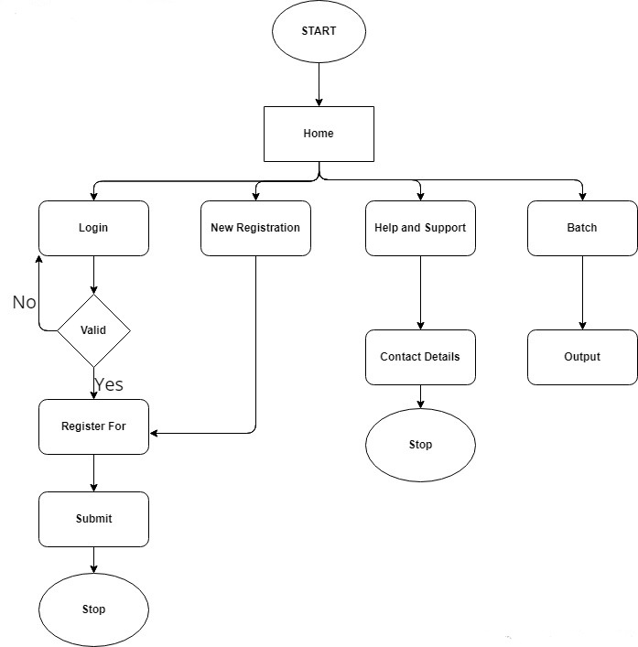

**3.HARDWARE AND SOFTWARE REQUIREMENTS**

**HARDWARE REQUIREMENTS**

PROCESSOR : i3 PROCESSOR

HARDDISK : 1TB

MONITOR : 15’Color

RAM : 4GB

**SOFTWARE REQUIREMENTS**

OPERATING SYSTEM : Windows 10

FRONT END : VS Code

BACK END : XAMP,PHP

LANGUAGES : HTML, CSS, JAVA SCRIPT

**4.MODULES OF ALUMNI WEBSITE**

This Alumni website has totally 5 modules. They are **Home Page, Login and Signup page, New Registration page, Batch page and Contact Page.**

**HOME PAGE**

The Home Page is the first page that is displayed after starting a Web Browser like Netscape’s Navigator or Microsoft’s Internet Explorer. This page is the root page where it guides to visit other submodules.This page contains the information about the Alumni site.

**CODING**

<html>

<head>

<title> ALUMINI SQUAD </title>

<meta name="viewport" content="width=device-width, initial-scale=1.0">

<link rel="stylesheet" href="Presentation.css">

<link rel="icon" href ="https://www.edarabia.com/wp-content/uploads/2013/08/university-of-madras-logo-india.jpg" type ="image/x-icon">

</head>

<body>

<style>

h2,h3,h4{

font-size: 40px;

font-family:'Montserrat',sans-serif ;

}

</style>

<div class ="first">

<br><br><br><br><br><br><br>

<p style="color:white"><strong>University of madras <br>Network system and Information Technology<br></strong></p>

<br>

<center>

<a href="manio.html" class="button">Login</a>

<a href="#" class="button">New registration</a>

<!-- <a href="#" class="button">News room</a>-->

<a href="#" class="button">Help and support</a>

<a href="abinaya.aspx" class="button">Batch</a>

</center>

<br>

<!--<div class="second"></div> -->

<br><br>

</div>

<br><br>

<h3 style ="color:rgb(81, 81, 235);position:relative;left:50px;">Aim and Objective</h3>

<div class = "fourth">

<br>

<p2><li>To utilize the rich experiences of old students of the college for the benefit and progress of the present students. </li>

 <li> To maintain website, publish periodical magazines or bulletins with valuable information useful to the members and students.</li>

<li> To bring together all the old students and the faculty of NSIT department to share their experiences with each other.</li><br>

<li>To create interest and motivate the alumni to participate in the progress of the Institute and make them contribute towards the enhancement of their Alma mater.</li><br>

<li>To hold and organize periodical alumni meetings in the premises of NSIT.</li><br>

<li>To provide career development and guidance.</li><br>

<li>To create interest and motivate the alumni to participate in the progress of the Institute and make them contribute towards the enhancement of their Alma mater.</li>

</p>

</div>

<br><br>

<h4 style ="color:rgb(81, 81, 235);position:relative;left:50px;">Alumni Gallery</h4>

<br><br>

<div class="container">

<!-- Full-width images with number text -->

<div class="mySlides">

<div class="numbertext">1 / 6</div>

<img src="C:\Users\Raghul mani M\Downloads\IMG-20221119-WA0077.jpg" style="width:50%;height: 50%;">

<div class="mySlides">

<div class="numbertext">2 / 6</div>

<img src= "C:\Users\Raghul mani M\Downloads\DSC07495 (1).JPG"style="width:50%;height: 50%;">

</div>

<div class="mySlides">

<div class="numbertext">3 / 6</div>

<img src= "C:\Users\Raghul mani M\Downloads\IMG_20221121_075328.png" style="width:50%;height: 50%;">

</div>

<div class="mySlides">

<div class="numbertext">4 / 6</div>

<img src= "C:\Users\Raghul mani M\Downloads\DSC07377.JPG" style="width:50%;height: 50%;">

</div>

<div class="mySlides">

<div class="numbertext">5 / 6</div>

<img src="C:\Users\Raghul mani M\Downloads\IMG-20221119-WA0104(1).jpg"style="width:50%;height: 50%;">

</div>

<div class="mySlides">

<div class="numbertext">6 / 6</div>

<img src= "C:\Users\Raghul mani M\Downloads\DSC07385.JPG" style="width:50%;height: 50%;">

</div>

<!-- Next and previous buttons -->

<a class="prev" onclick="plusSlides(-1)">&#10094;</a>

<a class="next" onclick="plusSlides(1)">&#10095;</a>

<!-- Image text -->

<div class="caption-container">

<p id="caption"></p>

<!-- Thumbnail images -->

<div class="row">

<div class="column">

<img class="demo cursor" src= "C:\Users\Raghul mani M\Downloads\IMG-20221119-WA0077.jpg" style="width: 50px;height:50px" onclick="currentSlide(1)" >

</div>

<div class="column">

<img class="demo cursor" src="C:\Users\Raghul mani M\Downloads\DSC07495 (1).JPG" style="width: 50px;height:50px" onclick="currentSlide(2)" >

</div>

<div class="column">

<img class="demo cursor" src="C:\Users\Raghul mani M\Downloads\IMG_20221121_075328.png" style="width: 50px;height:50px" onclick="currentSlide(3)" >

</div>

<div class="column">

<img class="demo cursor" src="C:\Users\Raghul mani M\Downloads\DSC07377.JPG" style="width: 50px;height:50px" onclick="currentSlide(4)" >

</div>

<div class="column">

<img class="demo cursor" src="C:\Users\Raghul mani M\Downloads\IMG-20221119-WA0104(1).jpg" style="width: 50px;height:50px" onclick="currentSlide(5)" >

</div>

<div class="column">

<img class="demo cursor" src="C:\Users\Raghul mani M\Downloads\DSC07385.JPG" style="width: 50px;height:50px" onclick="currentSlide(6)" >

</div>

</div>

</div>

<br><br><br><br>

<script>

let slideIndex = 1;

showSlides(slideIndex);

function plusSlides(n) {

showSlides(slideIndex += n);

}

function currentSlide(n) {

showSlides(slideIndex = n);

}

function showSlides(n) {

let i;

let slides = document.getElementsByClassName("mySlides");

let dots = document.getElementsByClassName("demo");

let captionText = document.getElementById("caption");

if (n > slides.length) {slideIndex = 1}

if (n < 1) {slideIndex = slides.length}

for (i = 0; i < slides.length; i++) {

slides[i].style.display = "none";

}

for (i = 0; i < dots.length; i++) {

dots[i].className = dots[i].className.replace(" active", "");

}

slides[slideIndex-1].style.display = "block";

dots[slideIndex-1].className += " active";

captionText.innerHTML = dots[slideIndex-1].alt;

}

</script>

<section class="footer">

<div class="link-row">

<div class="address-column">

<h3>UNIVERSITY OF MADRAS

<br>NETWORK SYSTEM AND INFORMATION TECHNOLOGY<br></h3>

</h3>

<p1>GUINDY CAMPAS , KOTTURPURAM , CHENNAI , TAMIL NADU - 600085</p1>

</div>

<div class="link-column">

<ul>

<li><span>Explore</span></li>

<li><a href="/websites">Websites</a></li>

<li><a href="/email">Examples</a></li>

<li><a href="/status">Pricing</a></li>

<li><a href="/security">Security</a></li>

</ul>

<ul>

<li><span>Resources</span></li>

<li>

<a href="/knowledge-base" rel="noopener noreferrer">Knowledge Base</a>

</li>

<li>

<a href="/api-documentation" rel="noopener noreferrer" >API Documentation</a>

</li>

<li>

<a href="/developers" rel="noopener noreferrer">Developers</a>

</li>

</ul>

<ul>

<li><span>Company</span></li>

<li>

<a href="/our-story" rel="noopener noreferrer">Our Story</a>

</li>

<li><a href="/events" rel="noopener noreferrer">Events</a></li>

<li><a href="/careers" rel="noopener noreferrer">Careers</a></li>

</ul>

</div>

</div>

<div class="social-row">

<div class="copyright-column">

<p>&copy; 2020-21 NSIT, Inc. All rights reserved.</p>

</div>

<div class="social-column">

<a href="your-instagram" target="_blank" rel="noopener noreferrer">Instagram</a >

<a href="your-twitter" target="_blank" rel="noopener noreference” >Twitter</a>

href="your-facebook-account" target="_blank" rel="noopener noreferrer">Facebook</a>

<a href="your-youtube" target="_blank" rel="noopener noreferrer >YouTube<\a>

</div>

</div>

</section>

</body>

</html>

**SCREENSHOTS**

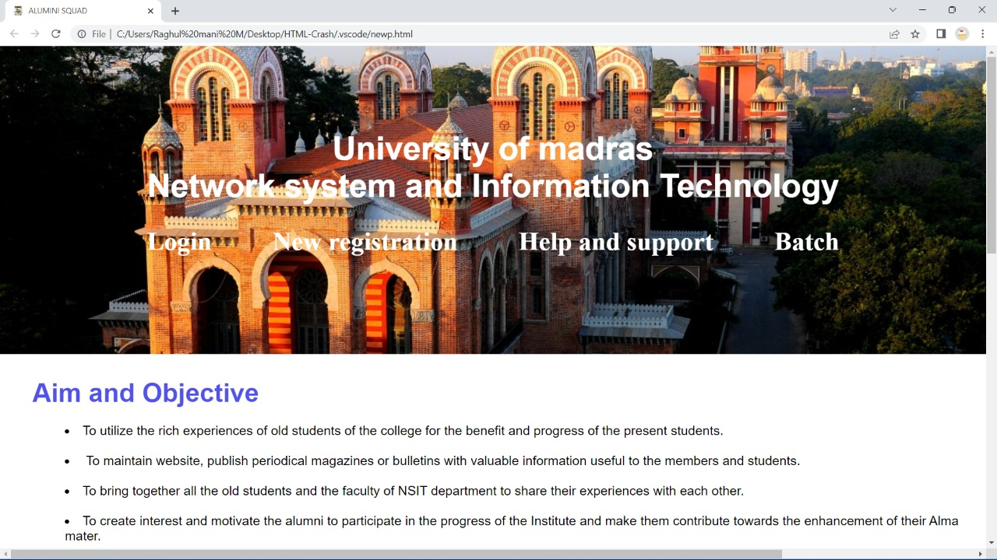

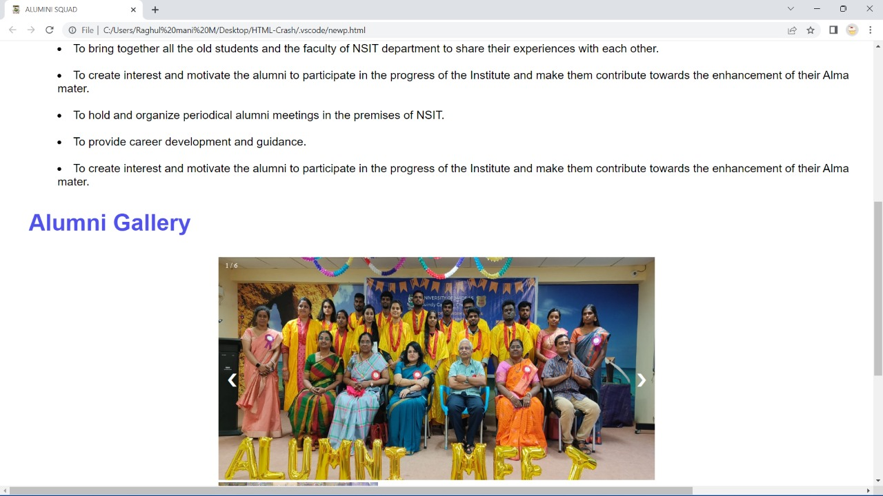

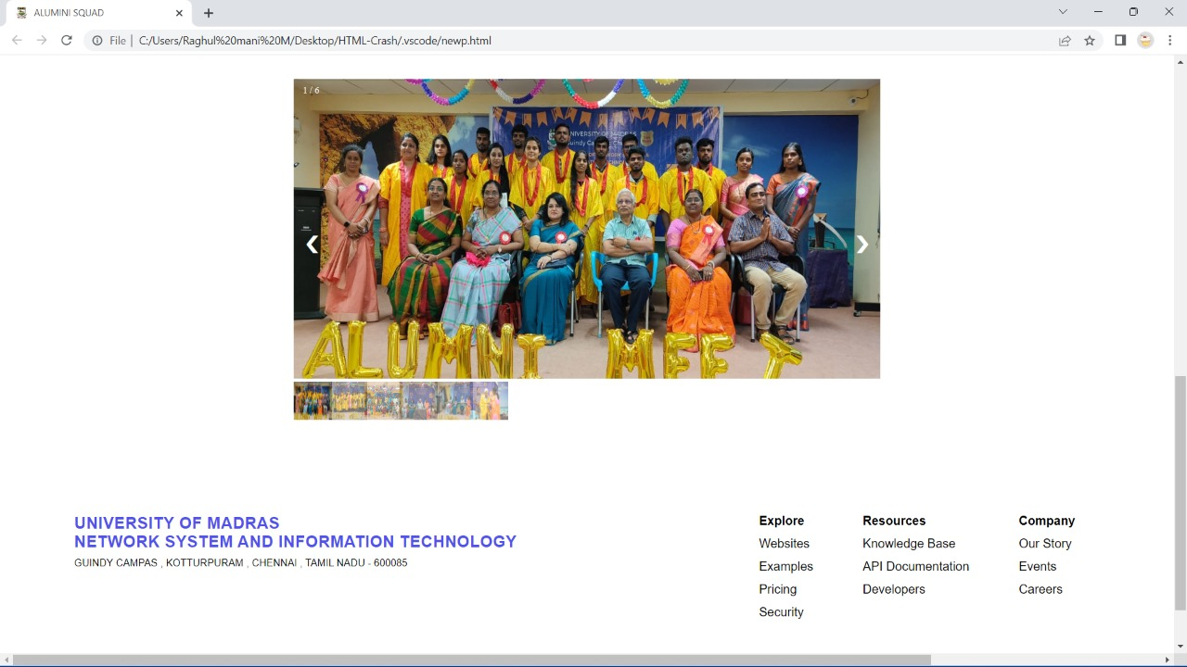

**LOGIN AND SIGNUP PAGE**

This Login page allows a user to gain access to an application by entering their username and password. The Signup page allows a user to register their email id and password for new registration.

**CODING**

<!DOCTYPE html>

<html lang="en">

<head>

<meta charset="UTF-8">

<meta http-equiv="X-UA-Compatible" content="IE=edge">

<meta name="viewport" content="width=device-width, initial-scale=1.0">

<script src="https://cdn.tailwindcss.com"></script>

<link rel="stylesheet" href="sangee.css">

<title>ALUMNI PRIDES</title>

<link rel="icon" href ="https://www.edarabia.com/wp-content/uploads/2013/08/university-of-madras-logo-india.jpg" type ="image/x-icon">

</head>

<body class="relative">

<header class="header bg-black flex justify-between items-center absolute">

<div class="text-white text-3xl translate-x-10 font-bold font-serif">

<p>ALUMNI REGISTER</p>

</div>

<div class="flex justify-center items-center text-gray-400 text-sm">

<p class="mx-5 border-b-4 border-black hover:border-white py-6 cursor-pointer uppercase hover:animate-ping">

<a href="raghul.html" class="button">Home</a></p>

<p class="mx-5 border-b-4 border-black hover:border-white py-6 cursor-pointer uppercase hover:animate-ping">

About</p>

<p class="mx-5 border-b-4 border-black hover:border-white py-6 cursor-pointer uppercase hover:animate-ping">

<a href="ganesh.html" class="button">Contact</a></p>

<p class="mx-5 border-b-4 border-black hover:border-white py-6 cursor-pointer uppercase hover:animate-ping">

Batch</p>

</div>

<div class="flex justify-center items-center text-white text-lg register_login">

<p class="px-5 uppercase cursor-pointer hover:font-bold hover:animate-pulse">

<a href="Sangee.html" class="button">LOG IN</a></P>

<p

class="px-5 uppercase font-bold cursor-pointer hover:font-normal border-l border-white hover:animate-pulse">

<a href="saran.html" class="button">Register</a></p>

</div>

</header>

<head>

<meta charset="UTF-8">

<meta name="viewport" content="width=device-width, initial-scale=1.0">

<title>Alumni Registration Form</title>

<link rel="stylesheet" href="style.css">

</head>

<body>

<head>

<meta charset="utf-8">

<title>Login and Registration Form </title>

<link rel="stylesheet" href="sangee.css">

<meta name="viewport" content="width=device-width, initial-scale=1.0">

</head>

<body>

<div class="wrapper">

<div class="title-text">

<div class="title login">

Login Form

</div>

<div class="title signup">

Signup Form

</div>

</div>

<div class="form-container">

<div class="slide-controls">

<input type="radio" name="slide" id="login" checked>

<input type="radio" name="slide" id="signup">

<label for="login" class="slide login">Login</label>

<label for="signup" class="slide signup">Signup</label>

<div class="slider-tab"></div>

</div>

<div class="form-inner">

<form action="#" class="login">

<div class="field">

<input type="text" placeholder="Email Address" required>

</div>

<div class="field">

<input type="password" placeholder="Password" required>

</div>

<div class="pass-link">

<a href="#">Forgot password? </a>

</div>

<div class="field btn">

<div class="btn-layer"></div>

<input type="submit" value="Login">

</div>

<div class="signup-link">

Not a member? <a href="">Signup now</a>

</div>

</form>

<form action="#" class="signup">

<div class="field">

<input type="text" placeholder="Email Address" required>

</div>

<div class="field">

<input type="password" placeholder="Password" required>

</div>

<div class="field">

<input type="password" placeholder="Confirm password" required>

</div>

<div class="field btn">

<div class="btn-layer"></div>

<input type="submit" value="Signup">

</div>

</form>

</div>

</div>

</div>

<script>

const loginText = document.querySelector(".title-text .login");

const loginForm = document.querySelector("form.login");

const loginBtn = document.querySelector("label.login");

const signupBtn = document.querySelector("label.signup");

const signupLink = document.querySelector("form .signup-link a");

signupBtn.onclick = (() => {

loginForm.style.marginLeft = "-50%";

loginText.style.marginLeft = "-50%";

});

loginBtn.onclick = (() => {

loginForm.style.marginLeft = "0%";

loginText.style.marginLeft = "0%";

});

signupLink.onclick = (() => {

signupBtn.click();

return false;

});

</script>

</body>

</html

<head>

<meta charset="UTF-8" />

<meta name="viewport" content="width=device-width, initial-scale=1.0" />

<title>Footer</title>

<link rel="stylesheet" href="sangee.css" />

</head>

<body>

<section class="footer">

<div class="link-row">

<div class="address-column">

<h3>UNIVERSITY OF MADRAS

<br>NETWORK SYSTEM AND INFORMATION TECHNOLOGY<br></h3>

</h3>

<p>GUINDY CAMPAS , KOTTURPURAM , CHENNAI , TAMIL NADU - 600085</p>

</div>

<div class="link-column">

<ul>

<li><span>Explore</span></li>

<li><a href="/websites">Department Infrastructur</a></li>

<li><a href="/email">Benefits</a></li>

<li><a href="/status">History</a></li>

</ul>

<ul>

<li><span>Resources</span></li>

<li>

<a href="/knowledge-base" rel="noopener noreferrer>Campas Drive<\a>

</li>

<li>

<a href="/api-documentation" rel="noopener noreference” >Enhancement</a>

</li>

<li>

<a href="/developers" rel="noopener noreferrer">INFO Details</a>

</li>

</ul>

<ul>

<li><span>Events</span></li>

<li>

<a href="/our-story" rel="noopener noreferrer">Our Story</a>

</li>

<li><a href="/events" rel="noopener noreferrer">Association</a></li>

<li><a href="/careers" rel="noopener noreferrer">Links</a></li>

</ul>

</div>

</div>

<div class="social-row">

<div class="copyright-column">

<p>&copy; 2020-21 NSIT, Inc. All rights reserved.</p>

</div>

<div class="social-column">

<a href="your-instagram" target="_blank" rel="noopener noreferrer">Instagram<\a >

<a href="your-twitter" target="_blank" rel="noopener noreferrer">Twitter</a>

<a href="your-facebook-account"

target="_blank"

rel="noopener noreferrer”>Facebook</a>

<a href="your-youtube" target="_blank" rel="noopener noreferrer">YouTube</a>

</div>

</div>

</section>

</body>

</html>

**SCREENSHOT**

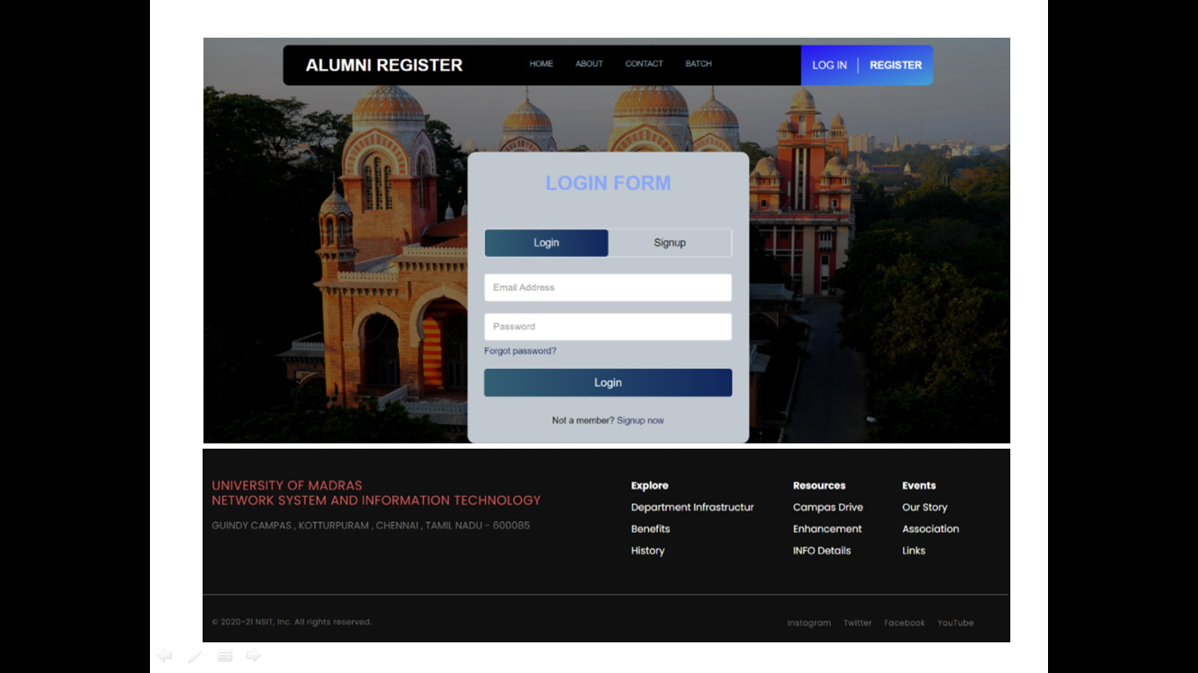

**NEW REGISTRATION PAGE**

This New Registration page helps the Alumni to enter their details for the following requirements.

**CODING**

<?php session_start(); ?>

<!DOCTYPE html>

<html lang="en">

<head>

<meta charset="UTF-8">

<meta http-equiv="X-UA-Compatible" content="IE=edge">

<meta name="viewport" content="width=device-width, initial-scale=1.0">

<script src="https://cdn.tailwindcss.com"></script>

<link rel="stylesheet" href="style.css">

<title>ALUMNI PRIDES</title>

<link rel="icon" href ="https://www.edarabia.com/wp-content/uploads/2013/08/university-of-madras-logo-india.jpg" type ="image/x-icon">

</head>

<body class="relative">

<header class="header bg-black flex justify-between items-center absolute">

<div class="text-white text-3xl translate-x-10 font-bold font-serif">

<p>ALUMNI REGISTER</p>

</div>

<div class="flex justify-center items-center text-gray-400 text-sm">

<p class="mx-5 border-b-4 border-black hover:border-white py-6 cursor-pointer uppercase hover:animate-ping">

<a href="raghul.html" class="button"> Home</a></p>

<p class="mx-5 border-b-4 border-black hover:border-white py-6 cursor-pointer uppercase hover:animate-ping">

About</p>

<p class="mx-5 border-b-4 border-black hover:border-white py-6 cursor-pointer uppercase hover:animate-ping">

<a href="ganesh.html" class="button">Contact</a></p>

<p class="mx-5 border-b-4 border-black hover:border-white py-6 cursor-pointer uppercase hover:animate-ping">

Batch</p>

</div>

<div class="flex justify-center items-center text-white text-lg register_login">

<p class="px-5 uppercase cursor-pointer hover:font-bold hover:animate-pulse">

<a href="Sangee.html" class="button">LOG IN</a></P>

<p

class="px-5 uppercase font-bold cursor-pointer hover:font-normal border-l border-white hover:animate-pulse">

Register</p>

</div>

</header>

<head>

<meta charset="UTF-8">

<meta name="viewport" content="width=device-width, initial-scale=1.0">

<title>Alumni Registration Form</title>

<link rel="stylesheet" href="style.css">

</head>

<body>

<div class="wrapper">

<?php

if(isset($_SESSION['status']))

{

echo $_SESSION['status'];

unset($_SESSION['status']);

}

<div class="title">

Registration Form

</div>

<div class="form">

<form action="saran.php" method="post">

<div class="inputfield">

<label>First Name</label>

<input type="text" class="input" name="firstname">

</div>

<div class="inputfield">

<label>Last Name</label>

<input type="text" class="input" name="lastname">

</div>

<div class="inputfield">

<label>Gender</label>

<div class="custom_select">

<select name="gender">

<option value="">Select</option>

<option value="male">Male</option>

<option value="female">Female</option>

</select>

</div>

</div>

<div class="inputfield">

<label>DOB</label>

<div class="customss_select">

<span name="dob">

<select name="month">

<option value="00">MONTH</option>

<option value="01">January</option>

<option value="02">February</option>

<option value="03">March</option>

<option value="04">April</option>

<option value="05">May</option>

<option value="06">June</option>

<option value="07">July</option>

<option value="08">August</option>

<option value="09">September</option>

<option value="10">October</option>

<option value="11">November</option>

<option value="12">December</option>

</select>

</span>

<span>

<select name="day">

<option value="00">DAY</option>

<option value="01">1</option>

<option value="02">2</option>

<option value="03">3</option>

<option value="04">4</option>

<option value="05">5</option>

<option value="06">6</option>

<option value="07">7</option>

<option value="08">8</option>

<option value="09">9</option>

<option value="10">10</option>

<option value="11">11</option>

<option value="12">12</option>

<option value="13">13</option>

<option value="14">14</option>

<option value="15">15</option>

<option value="16">16</option>

<option value="17">17</option>

<option value="18">18</option>

<option value="19">19</option>

<option value="20">20</option>

<option value="21">21</option>

<option value="22">22</option>

<option value="23">23</option>

<option value="24">24</option>

<option value="25">25</option>

<option value="26">26</option>

<option value="27">27</option>

<option value="28">28</option>

<option value="29">29</option>

<option value="30">30</option>

<option value="31">31</option>

</select>

</span>

<span>

<select name="year">

<option value="00">YEAR</option>

<option value="2005">2005</option>

<option value="2004">2004</option>

<option value="2003">2003</option>

<option value="2002">2002</option>

<option value="2001">2001</option>

<option value="2000">2000</option>

<option value="1999">1999</option>

<option value="1998">1998</option>

<option value="1997">1997</option>

<option value="1996">1996</option>

<option value="1995">1995</option>

<option value="1994">1994</option>

<option value="1993">1993</option>

<option value="1992">1992</option>

<option value="1991">1991</option>

</select>

</span>

</div>

</div>

<div class="inputfield">

<label>Batch</label>

<div class="customs_select">

<select name="batch">

<option value="">Select</option>

<option value="19">2019-21</option>

<option value="21">2020-22</option>

<option value="22">2021-23</option>

</select>

</div>

</div>

<div class="inputfield">

<label>Email Address</label>

<input type="text" class="input" name="email">

</div>

<div class="inputfield">

<label>Phone Number</label>

<input type="text" class="input" name="phone">

</div>

<div class="inputfield">

<label>Address</label>

<textarea class="textarea" name="address"></textarea>

</div>

<div class="inputfield">

<label>Designation</label>

<input type="text" class="input" name="designation">

</div>

<div class="inputfield terms">

<label class="check">

<input type="checkbox">

<span class="checkmark"></span>

</label>

<p>Agreed to terms and conditions</p>

</div>

<div class="inputfield">

<input type="submit" name="register" value="Register" class="btn">

</div>

</form>

</div>

</div>

</body>

</html>

<head>

<meta charset="UTF-8" />

<meta name="viewport" content="width=device-width, initial-scale=1.0" />

<title>Footer</title>

<link rel="stylesheet" href="style.css" />

</head>

<body>

<section class="footer">

<div class="link-row">

<div class="address-column">

<h3>UNIVERSITY OF MADRAS

<br>NETWORK SYSTEM AND INFORMATION TECHNOLOGY<br></h3>

</h3>

<p>GUINDY CAMPAS , KOTTURPURAM , CHENNAI , TAMIL NADU - 600085</p>

</div>

<div class="link-column">

<ul>

<li><span>Explore</span></li>

<li><a href="/websites">Department Infrastructur</a></li>

<li><a href="/email">Benefits</a></li>

<li><a href="/status">History</a></li>

</ul>

<ul>

<li><span>Resources</span></li>

<li>

<a href="/knowledge-base" rel="noopener noreferrer">Campas Drive</a>

</li>

<li>

<a href="/api-documentation" rel="noopener noreferrer">Enhancement</a>

</li>

<li>

<a href="/developers" rel="noopener noreferrer">INFO Details</a>

</li>

</ul>

<ul>

<li><span>Events</span></li>

<li>

<a href="/our-story" rel="noopener noreferrer">Our Story</a>

</li>

<li><a href="/events" rel="noopener noreferrer">Association</a></li>

<li><a href="/careers" rel="noopener noreferrer">Links</a></li>

</ul>

</div>

</div>

<div class="social-row">

<div class="copyright-column">

<p>&copy; 2020-21 NSIT, Inc. All rights reserved.</p>

</div>

<div class="social-column">

<a href="your-instagram" target="_blank" rel="noopener noreferrer">Instagram</a>

<a href="your-twitter" target="_blank" rel="noopener noreferrer">Twitter</a>

<a href="your-facebook-account"

target="_blank"

rel="noopener noreferrer">Facebook</a>

<a href="your-youtube" target="_blank" rel="noopener noreferrer">YouTube</a>

</div>

</div>

</section>

</body>

</html>

**SCREENSHOT**

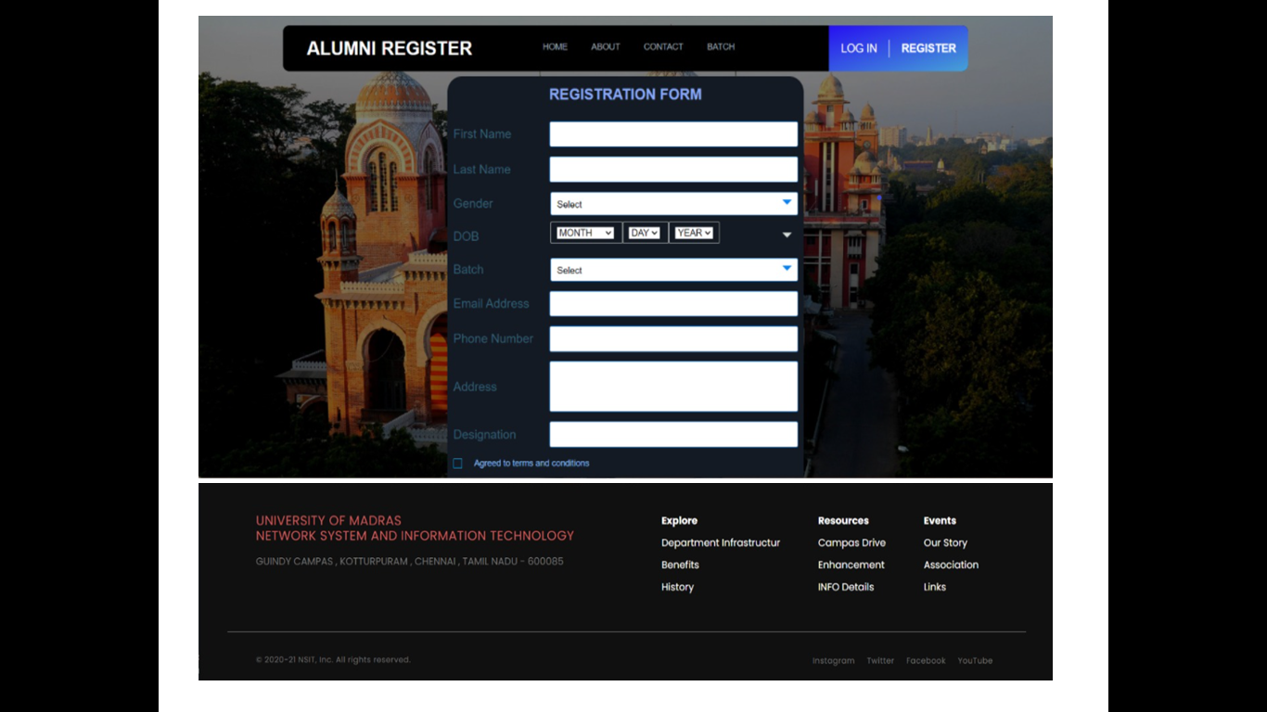

**BATCH PAGE**

This page displays all information about the Alumni’s including their current designation, Phone number of all the passed out batch.

CODING

<!DOCTYPE html>

<html lang="en">

<head>

<meta charset="UTF-8">

<meta http-equiv="X-UA-Compatible" content="IE=edge">

<meta name="viewport" content="width=device-width, initial-scale=1.0">

<script src="https://cdn.tailwindcss.com"></script>

<link rel="stylesheet" href="sangee.css">

<title>ALUMNI PRIDES</title>

<link rel="icon" href ="https://www.edarabia.com/wp-content/uploads/2013/08/university-of-madras-logo-india.jpg" type ="image/x-icon">

</head>

<body class="relative">

<header class="header bg-black flex justify-between items-center absolute">

<div class="text-white text-3xl translate-x-10 font-bold font-serif">

<p>ALUMNI REGISTER</p>

</div>

<div class="flex justify-center items-center text-gray-400 text-sm">

<p class="mx-5 border-b-4 border-black hover:border-white py-6 cursor-pointer uppercase hover:animate-ping">

<a href="raghul.html" class="button">Home</a></p>

<p class="mx-5 border-b-4 border-black hover:border-white py-6 cursor-pointer uppercase hover:animate-ping">

About</p>

<p class="mx-5 border-b-4 border-black hover:border-white py-6 cursor-pointer uppercase hover:animate-ping">

<a href="ganesh.html" class="button">Contact</a></p>

<p class="mx-5 border-b-4 border-black hover:border-white py-6 cursor-pointer uppercase hover:animate-ping">

Batch</p>

</div>

<div class="flex justify-center items-center text-white text-lg register_login">

<p class="px-5 uppercase cursor-pointer hover:font-bold hover:animate-pulse">

<a href="Sangee.html" class="button">LOG IN</a></P>

<p

class="px-5 uppercase font-bold cursor-pointer hover:font-normal border-l border-white hover:animate-pulse">

<a href="saran.html" class="button">Register</a></p>

</div>

</header>

<head>

<meta charset="UTF-8">

<meta http-equiv="X-UA-Compatible" content="IE=edge">

<meta name="viewport" content="width=device-width, initial-scale=1.0">

<title>Responsive Card Slider</title>

<!-- Swiper CSS -->

<link rel="stylesheet" href="css/swiper-bundle.min.css">

<!-- CSS -->

<link rel="stylesheet" href="css/style.css">

</head>

<body>

<div class="slide-container swiper">

<div class="slide-content">

<div class="card-wrapper swiper-wrapper">

<div class="card swiper-slide">

<div class="image-content">

<span class="overlay"></span>

<div class="card-image">

<img src="14.jpg" alt="" class="card-img">

</div>

</div>

<div class="card-content">

<h2 class="name">SARANRAJ V</h2>

<p class="description"><br>DESIGNATION:M.Sc(IT)</br>

<br> PHONE:9789685039</br>

<br>EMAIL:saran1212raj@gmail.com</br></p>

<button class="button">View More</button>

</div>

</div>

<div class="card swiper-slide">

<div class="image-content">

<span class="overlay"></span>

<div class="card-image">

<img src="12.png" alt="" class="card-img">

</div>

</div>

<div class="card-content">

<h2 class="name">SANGEETHA B</h2>

<p class="description"><br>DESIGNATION:M.Sc(IT)</br>

<br> PHONE:9791076293</br>

<br>EMAIL:sangeethabalasundaram@gmail.com</br></p>

<button class="button">View More</button>

</div>

</div>

<div class="card swiper-slide">

<div class="image-content">

<span class="overlay"></span>

<div class="card-image">

<img src="15.png" alt="" class="card-img">

</div>

</div>

<div class="card-content">

<h2 class="name">GANESH</h2>

<p class="description"><br>DESIGNATION:M.Sc(IT)</br>

<br> PHONE:9944033190</br>

<br>EMAIL:ganeshyadhav@gmail.com</br></p>

<button class="button">View More</button>

</div>

</div>

<div class="card swiper-slide">

<div class="image-content">

<span class="overlay"></span>

<div class="card-image">

<img src="13.png" alt="" class="card-img">

</div>

</div>

<div class="card-content">

<h2 class="name">RAGHUL MANI</h2>

<p class="description"><br>DESIGNATION:M.Sc(IT)</br>

<br> PHONE:9150580631</br>

<br>EMAIL:raghulmanimba@gmail.com</br></p>

<button class="button">View More</button>

</div>

</div>

<div class="card swiper-slide">

<div class="image-content">

<span class="overlay"></span>

<div class="card-image">

<img src="11.jpg" alt="" class="card-img">

</div>

</div>

<div class="card-content">

<h2 class="name">ABINAYA S</h2>

<p class="description"><br>DESIGNATION:M.Sc(IT)</br>

<br> PHONE:9003676342</br>

<br>EMAIL:abinayaash06@gmail.com</br></p>

<button class="button">View More</button>

</div>

</div>

</div>

</div>

<div class="swiper-button-next swiper-navBtn"></div>

<div class="swiper-button-prev swiper-navBtn"></div>

<div class="swiper-pagination"></div>

</div>

</body>

<!-- Swiper JS -->

<script src="js/swiper-bundle.min.js"></script>

<!-- JavaScript -->

<script src="js/script.js"></script>

</html>

**SCREENSHOT**

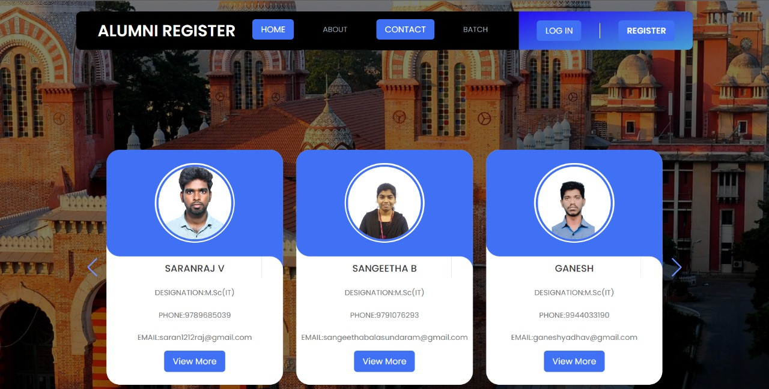

**CONTACT PAGE**

This page is where the user can communicate with the administrator for any query. It contains the address, phone number and email address of the department.

**CODING**

<!DOCTYPE html>

<html lang="en">

<head>

<meta charset="UTF-8">

<meta http-equiv="X-UA-Compatible" content="IE=edge">

<meta name="viewport" content="width=device-width, initial-scale=1.0">

<script src="https://cdn.tailwindcss.com"></script>

<link rel="stylesheet" href="ganesh.css">

<title>ALUMNI PRIDES</title>

<link rel="icon" href ="https://www.edarabia.com/wp-content/uploads/2013/08/university-of-madras-logo-india.jpg" type ="image/x-icon">

</head>

<body class="relative">

<header class="header bg-black flex justify-between items-center absolute">

<div class="text-white text-3xl translate-x-10 font-bold font-serif">

<p>ALUMNI REGISTER</p>

</div>

<div class="flex justify-center items-center text-gray-400 text-sm">

<p class="mx-5 border-b-4 border-black hover:border-white py-6 cursor-pointer uppercase hover:animate-ping">

Home</p>

<p class="mx-5 border-b-4 border-black hover:border-white py-6 cursor-pointer uppercase hover:animate-ping">

About</p>

<p class="mx-5 border-b-4 border-black hover:border-white py-6 cursor-pointer uppercase hover:animate-ping">

<a href="ganesh.html" class="button">Contact</a></p>

<p class="mx-5 border-b-4 border-black hover:border-white py-6 cursor-pointer uppercase hover:animate-ping">

Batch</p>

</div>

<div class="flex justify-center items-center text-white text-lg register_login">

<p class="px-5 uppercase cursor-pointer hover:font-bold hover:animate-pulse">

<a href="Sangee.html" class="button">LOG IN</a></P>

<p

class="px-5 uppercase font-bold cursor-pointer hover:font-normal border-l border-white hover:animate-pulse">

Register</p>

</div>

</header>

<head>

<meta name="viewport" content="width=device-width, initial-scale=1.0">

<title>Help and Support Page</title>

<link href="https://stackpath.bootstrapcdn.com/font-awesome/4.7.0/css/font-awesome.min.css" rel="stylesheet" integrity="sha384-wvfXpqpZZVQGK6TAh5PVlGOfQNHSoD2xbE+QkPxCAFlNEevoEH3Sl0sibVcOQVnN" crossorigin="anonymous">

<link rel="stylesheet" type="text/css" href="ganesh.css">

</head>

<body>

<section class="contact">

<div class="content">

<h2>Contact Us</h2>

</div>

<div class="container">

<div class="contactInfo">

<div class="box">

<div class="icon"><i class="fa fa-map-marker" aria-hidden="true"></i></div>

<div class="text">

<h3><b>Address</b></h3>

<p><b>Department of Network System and Information Technology,<br>Guindy Campus,University of Madras,<br>Chennai-600025,INDIA</b></p>

</div>

</div>

<div class="box">

<div class="icon"><i class="fa fa-phone" aria-hidden="true"></i></div>

<div class="text">

<h3><b>Phone</b></h3>

<p><b>044-22202907</b></p>

</div>

</div>

<div class="box">

<div class="icon"><i class="fa fa-envelope-o" aria-hidden="true"></i></div>

<div class="text">

<h3><b>Email</b></h3>

<p><b>nsit.unom@gmail.com</b></p>

</div>

</div>

</div>

<div class="contactForm">

<form>

<h2>Send Message</h2>

<div class="inputBox">

<input type="text" name="" required="required">

<span>Full Name</span>

</div>

<div class="inputBox">

<input type="text" name="" required="required">

<span>Email</span>

</div>

<div class="inputBox">

<textarea required="required"></textarea>

<span>Type your Message...</span>

</div>

<div class="inputBox">

<input type="submit" name="" value="Send">

</div>

</form>

</div>

</div>

</section>

</body>

</html>

<head>

<meta charset="UTF-8" />

<meta name="viewport" content="width=device-width, initial-scale=1.0" />

<title>Footer</title>

<link rel="stylesheet" href="ganesh.css" />

</head>

<body>

<section class="footer">

<div class="link-row">

<div class="address-column">

<h3>UNIVERSITY OF MADRAS

<br>NETWORK SYSTEM AND INFORMATION TECHNOLOGY<br></h3>

</h3>

<p>GUINDY CAMPAS , KOTTURPURAM , CHENNAI , TAMIL NADU - 600085</p>

</div>

<div class="link-column">

<ul>

<li><span>Explore</span></li>

<li><a href="/websites">Department Infrastructur</a></li>

<li><a href="/email">Benefits</a></li>

<li><a href="/status">History</a></li>

</ul>

<ul>

<li><span>Resources</span></li>

<li>

<a href="/knowledge-base" rel="noopener noreferrer">Campas Drive</a>

</li>

<li>

<a href="/api-documentation" rel="noopener noreferrer">Enhancement</a>

</li>

<li>

<a href="/developers" rel="noopener noreferrer">INFO Details</a>

</li>

</ul>

<ul>

<li><span>Events</span></li>

<li>

<a href="/our-story" rel="noopener noreferrer">Our Story</a>

</li>

<li><a href="/events" rel="noopener noreferrer">Association</a></li>

<li><a href="/careers" rel="noopener noreferrer">Links</a></li>

</ul>

</div>

</div>

<div class="social-row">

<div class="copyright-column">

<p>&copy; 2020-21 NSIT, Inc. All rights reserved.</p>

</div>

<div class="social-column">

<a href="your-instagram" target="_blank" rel="noopener noreferrer">Instagram</a>

<a href="your-twitter" target="_blank" rel="noopener noreferrer">Twitter</a>

<a

href="your-facebook-account" target="_blank" rel="noopener noreferrer">Twitter</a>

<a href="your-youtube" target="_blank" rel="noopener noreferrer">YouTube</a>

</div>

</div>

</section>

</body>

</html>

**SCREENSHOT**

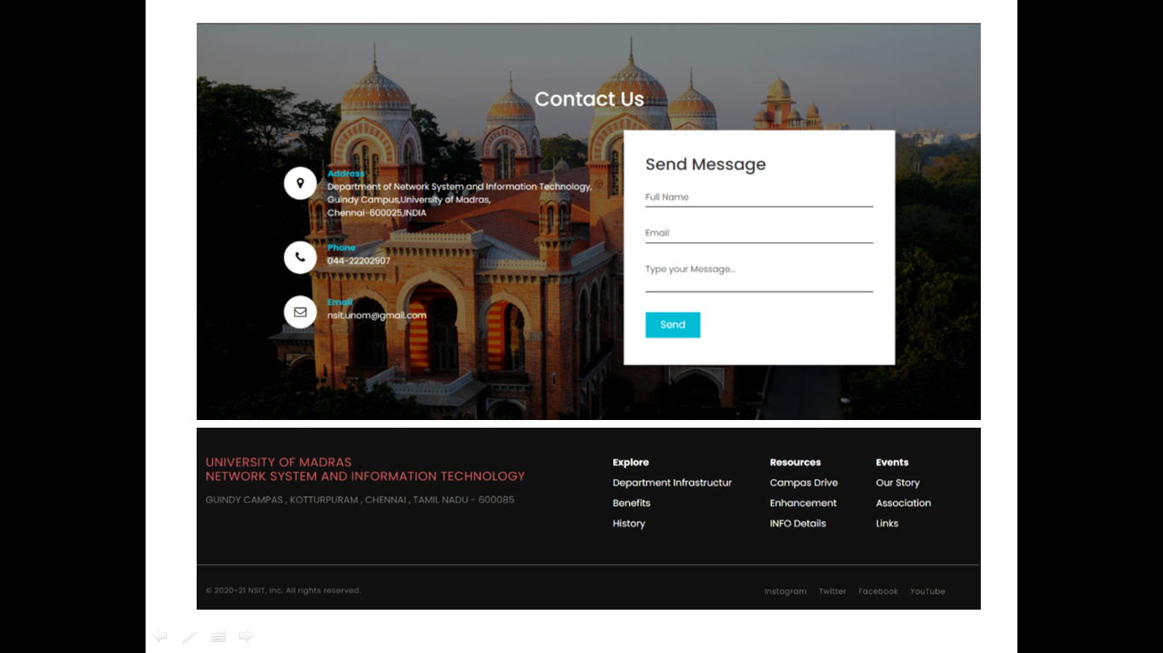

**CONCLUSION**

In present work, we are developing alumni web application to established interaction between alumni and institutes. This web application is developing in Word press with the help of some inbuilt plugins and some own developed plugins. The web application serve as a useful site to any institution and Alumni to know what is going on in our college and can also know about the various opportunities of the outer world to the institute. This portal provides access to only authorized users. The web application helps admin to generate report regarding accreditation (NAAC,NBA) based on database.